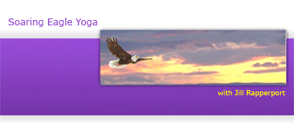
Early Childhood Yoga for Teachers and Parents
Registration Form
When: Saturday, September 15, 2012
Where: The Yoga Center of Key Biscayne, 971 Crandon Blvd, Suite 911, Key Biscayne Fl
Directions: take Crandon Blvd into Key Biscayne. Go toward Bill Bags State Park; make a LEFT just after W. Mashta Drive into the building’s parking lot. Park and walk up the stairs.
NOTE: THERE ARE NO SIGNS on the street for the studio or for the office building where the studio is located. You will make a left and enter a parking garage and will see US Postal trucks in the parking lot. Park and walk up the stairs and look for suite 911. It’s a very cute mall, but hard to see from the street.
Bring water bottle, snacks, and notebook. Dress comfortably.
If you have a yoga mat, please bring it.

Name:
Address:
City, State, Zip
Phone(s):
Email:
- Do you have children?
- If you have children, how many?
- Are you a classroom teacher or do you work in a child care center?
- If so, what ages/grades do you teach?
- Are you interested in teaching yoga to children?

Please take a moment and think about what you would like to receive from your time in this training.
For Example: My intention is to manage my outbursts at home
My intention is to foster a healthy self esteem in my child.
To have more fun with my child/children.
To begin teaching children yoga.
My Intentions for this training are:

